DAYANANDA SAGAR UNIVERSITY

**DEPARTMENT OF COMPUTER SCIENCE & TECHNOLOGY SCHOOL OF ENGINEERING**

**DAYANANDA SAGAR UNIVERSITY, KUDLU GATE**

**BANGALORE - 560068**



A PROJECT REPORT

ON

IDEA VOTING

**SUBMITTED TO THE IV SEMESTER**

**FULL STACK DEVELOPMENT (20CS2406) 2022**

**BACHELOR OF TECHNOLOGY**

**IN**

**COMPUTER SCIENCE & TECHNOLOGY**

***Submitted by:***

MOHITH. B [ENG20CT0014]

VINAY .TS [ENG20CT0031]

SAI SKANDHA SHARAVANAN [ENG20CT0023]

MANOGNA YARAGAL [ENG20CT0013]

RAKSHITH RAJ BG [ENG20CT0021]

***Under the supervision of* Dr. Sindhu P Menon Professor**

**Dept of CSE**



**CERTIFICATE**

This is to certify that the report on Full Stack Development entitled **“Idea Voting” is** being submitted to the Department of Computer Science and Technology, School of Engineering, Dayananda Sagar University, Bangalore, for the IV semester B. Tech CST of this university during the academic year 2021-2022

.

***Date***: 22/05/2022

***Signature of the Faculty in Charge***

***Signature of the Chairman***

**Table of Contents**

|  |
| --- |
| **Table of Contents** |
| **1 Introduction** |
| **2 Requirement Specification** |
| 2.1 Software Requirement Specification  **3. Analysis and Design**   * 1. Website Application Structure   2. Functional Description of Major Modules |
| **4 Implementation** |
| * 1. Programming languages for implementation   2. Libraries used |
| **5 Applications and Conclusion** |
| * 1. Applications   2. Snapshots   3. Conclusion |

|  |
| --- |
| **ABSTRACT**  Every person has their own unique ideas which they plan to implement. But most ideas may fail to implement due to the lack of a better feasibility study before the implementation which reduces the success rate of a particular idea. The feasibility study helps them to be aware of the demand that their idea has in the market & also helps them to know who are all the existing competitors with the same idea. This creates better awareness among them so that they can change their plans to implement their ideas successfully. A feasibility study might uncover new ideas that could completely change a project’s scope. It’s best to make these determinations in advance, rather than to jump in & learn that the idea won’t work. Thereby conducting a feasibility study is always beneficial for ideas as it gives the people a clear picture of their proposed idea.    A better feasibility study involves conducting a survey among various users so that the other users analyzing the idea can give their own perspectives & suggestions so that the person with that idea can get a better awareness of the clear picture of his proposed idea. So this is where our platform comes into the picture. Through our platform, a person with ideas can post their ideas which will be available as a post for other users who can vote on that idea & give their own suggestions thereby giving an opportunity for the person who posted that idea to know the exact demand for his idea in the market. Therefore this helps them implement their ideas with better feasibility study & in an efficient manner so that their ideas can have a huge success rate in the market. |

1. **INTRODUCTION:**
   * What actually is idea voting?

Idea voting is a website on which a user can post their ideas so that they can get feedback from other users. The rating system is also provided in such a way that the best idea can get rewards.

For example:

If a user needs clarification about his/her idea, they can post their ideas on our website which will be available as a post for other people who can vote and give their suggestions for that particular idea thereby helping the person who posted the idea to make a better feasibility study so that their idea will be implemented successfully.

1. **REQUIREMENT SPECIFICATION**
   * Laptop with moderate specification
   * Stable Internet connection
   * Suitable IDE

2.1 Software Requirement Specification:-

* + Frontend – React
  + Backend – Supabase, Firebase using client-side Javascript
  + Database – Supabase
  + Authentication – Firebase

1. **ANALYSIS & DESIGNS:**

**3.1Website Application Structure**

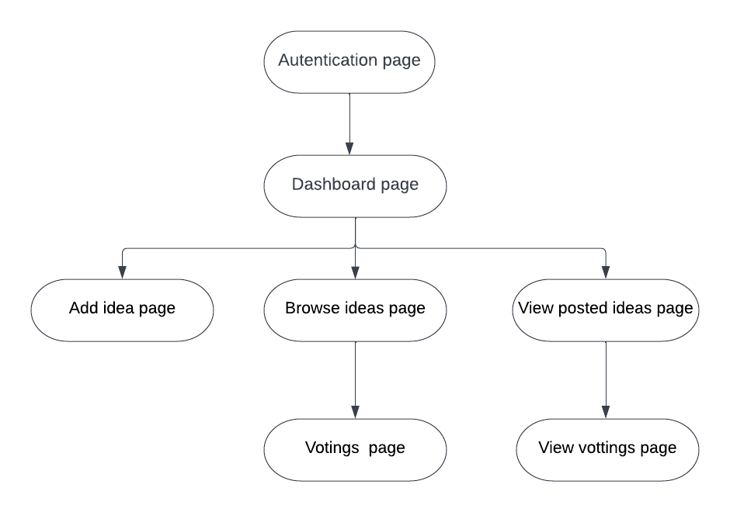

* 1. **Functional Description**

1. Authentication page:-

Algorithm:-

1. Get the email & Password from the user
2. Check whether the user exists or not using firebase.createEmailandPassword function
3. If the user does not exists then create the same user using the same above function.
4. If the user exists then sign in the user using firebase.signinWithEmailandPassword

Code:

createUserWithEmailAndPassword(auth, email, password)

.then(res => { setUser(res.user);

localStorage.setItem('user', user.email); setError("");

})

.catch(err => { console.log(err);

if(err.code == "auth/email-already-in-use") {

signinWithEmailandPassword(auth, email, password);

}else {

setError("There was an error. Please try again after some time with stable internet connection");

}

});

1. Add idea page

Algorithm:

* 1. Get the title, category, & description of an idea
  2. Post the details to the database using superbase library
  3. Once posted successfully, reload the page

Code:

const { data, error } = await supabase

.from('useridea')

.insert([

{ email: usremail, title: ideatitle , category: ideacategory , description: ideades } ]);

if(error) {

console.log(error);

setError("There was an error. Please try again after sometime");

}

if(data[0]) {

setError("");

console.log(“Success”);

window.location.reload();

}

1. Voting's Page

Algorithm

1. Get the title of the idea to vote
2. Save the voting in the range of 100 and suggestion to ‘uservote’ table of the supabase database using supabase library

Code:

const { data, error } = await supabase.from('uservote')

.insert([

{ voteby: useremail, vote: vote , suggestion: suggestion , idea: voteemail, title: votetitle }

]);

1. **IMPLEMENTATION:**

**4.1 Programming language for implementation:-** React JS

**4.2 Libraries used**

1. React
2. React Router Dom
3. Supabase Client
4. Firebase Client
5. Material UI
6. APPLICATION & CONCLUSION:

5.1 Application

* Can be used to get suggestions from various experts for a particular idea
* Can also be used to track demand for a particular idea
* Can be used to perform a feasibility study for any startup ideas
* Can get users/viewers perspectives on a certain idea
* Can also be used as a platform to introduce the real-world application

**5.2 Snapshots**:

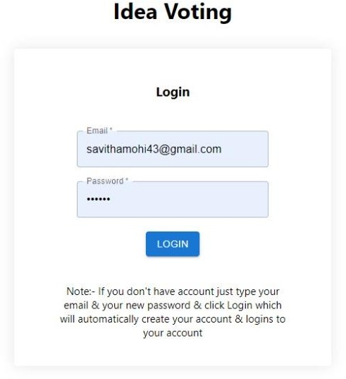

Fig- 4.1. Authentication page

This page is used to login or register for the dashboard. If the user account does not exist it automatically creates a new account and automatically logins to the dashboard.

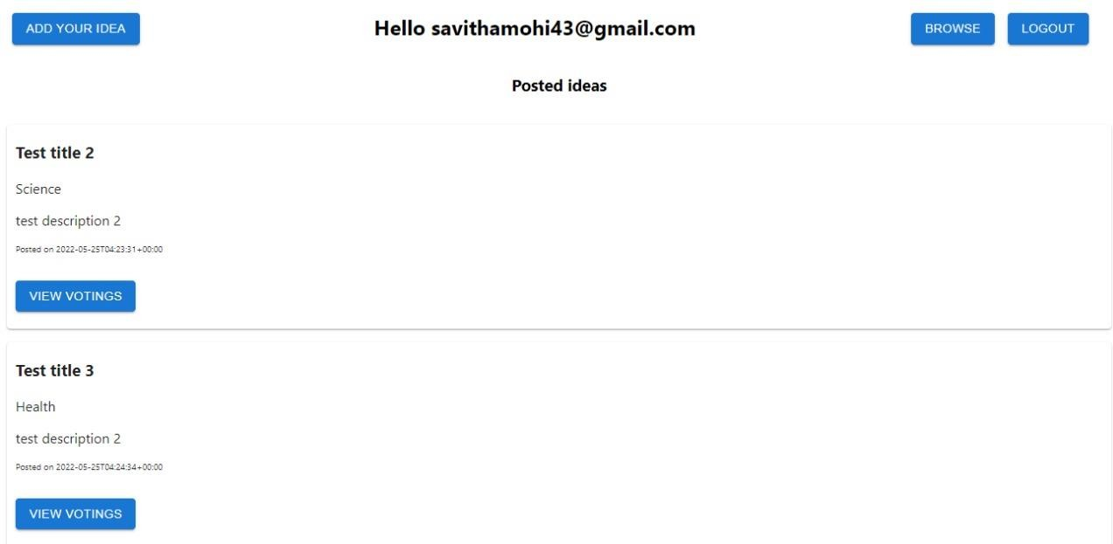

Fig – 4.2. Dashboard page

This is a Dashboard page where users can post & view votes for their ideas & can also browse other ideas to vote & give their suggestions.

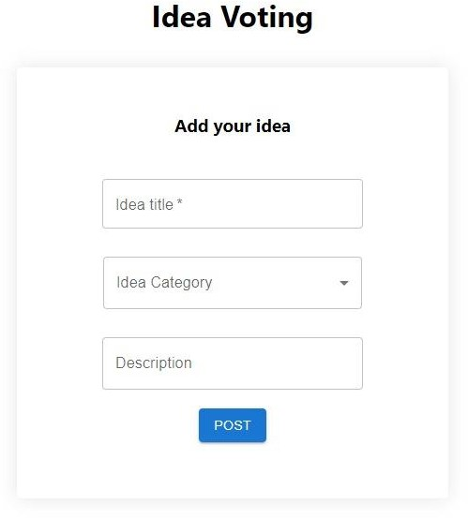

Fig. 4.3. Add idea page

This is a page where user can post their ideas so that they can get votes & suggestions from other viewers/users.

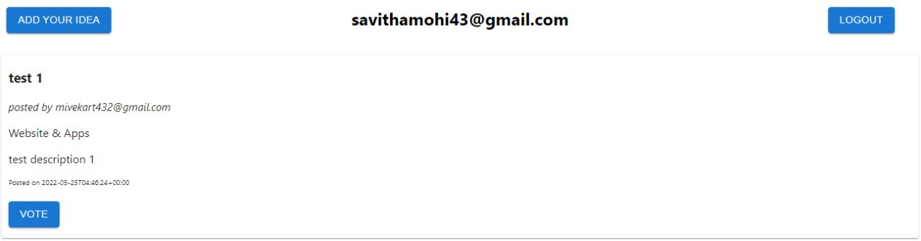

Fig. 4.4. Browse ideas page

This is a Browse ideas page where users can browse the ideas posted by other users so that they can vote & give their suggestion.

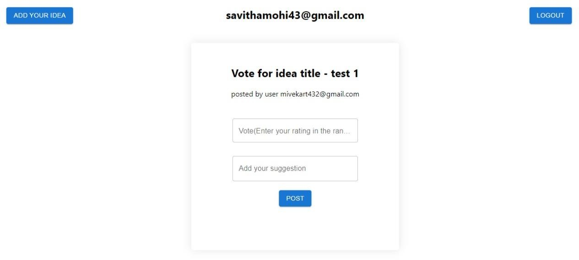

Fig. 4.5. Vote for idea

This is a page where users can vote & give suggestions for the selected idea title

5.3 Conclusion

Our platform can thereby help people with various ideas in various domains to get audience perspective and also suggestions from various experts so that they can further improvise their ideas, thereby forming most efficient idea to achieve their respective goal.